19.66: a) 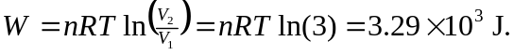

b) See Problem 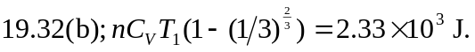

c)

d)
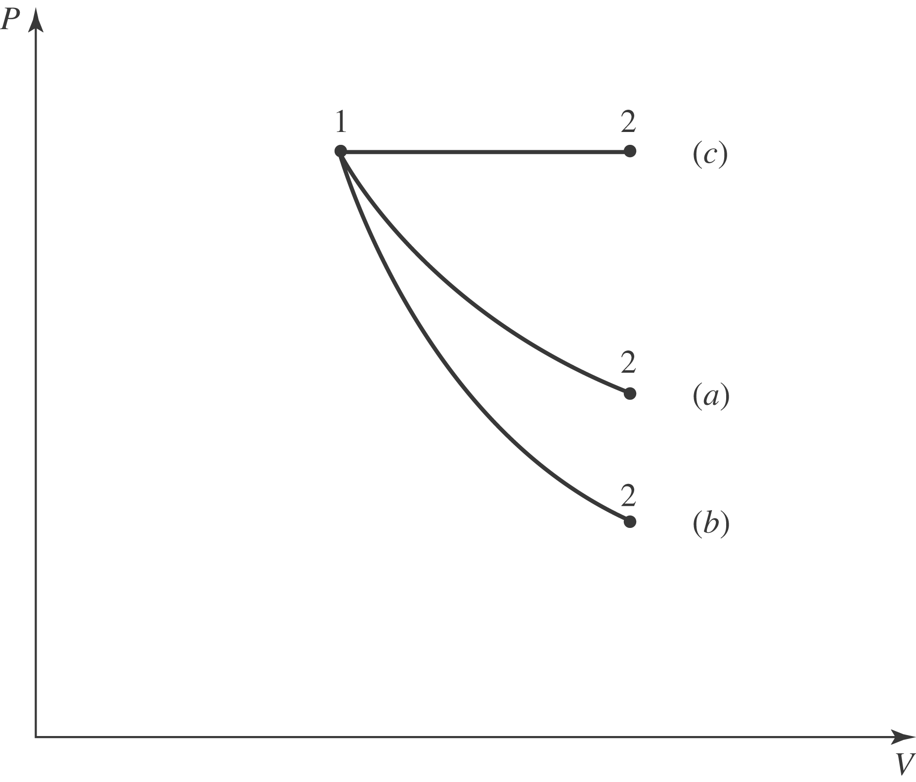

The most work done is in the isobaric process, as the pressure is maintained at its original value. The least work is done in the abiabatic process. e) The isobaric process involves the most work and the largest temperature increase, and so requires the most heat. Adiabatic processes involve no heat transfer, and so the magnitude is zero. f) The isobaric process doubles the Kelvin temperature, and so has the largest change in internal energy. The isothermal process necessarily involves no change in internal energy.

